REQUEST FOR QUOTATION

From: Norwegian Refugee Council (NRC)
Kosti Office, Al-Andalus Area, Al Andalus Street, North of WFP, East from COR
E-mail: mohammed.alkhidir@nrc.no - sd.procurement@nrc.no
Mobile: +24919938646 +249911219777

Date: 01/12/2022
No. of pages including this page: 6

Subject: Procurement of Sanitation and Hygiene Kits to Khor Ajwal IDPs camp – White Nile State – Eljabalain locality

PR Reference number: 8400202

Manner of Submission:

Please submit your quotation in accordance with the requirements detailed below by hand delivery to Norwegian Refugee Council Kosti Office, Al-Andalus Area, Al Andalus Street, North of WFP, and East from CORE OR send e-mail for above mentioned e-mails with subject RFQ-8400202 bidding

Deadline for submission of quotations is 04/12/2022 at 09:00 am. Companies or suppliers who do not submit their quotation by this deadline will not be considered.

Requirements:
The office of the Norwegian Refugee Council invites your company to make a firm offer for the following items (please see attached Annex-1):

Item | Unit | Quantity | Unit Price | Total Amount
Procurement of child potties for children under 4 years | Piece | 500
Procurement of 200 litter steel barrels – open top for Garbage collection | Piece | 40
Procurement of hand held broom with wooden handle | Piece | 20
Procurement of good quality bucket (15L capacity plastic) | Piece | 20
Procurement of good quality hard held Bruch for toilet cleaning | Piece | 20
Procurement of good quality 4 litter liquid soap bottle | Piece | 150
Procurement of gum boots | Piece | 20
Procurement of dirt scoopers | Piece | 20
procurement of good quality hand held broom Bruch with scooper with led (set) | Piece | 50
Delivery to Khor Ajwal IDPs camp – White Nile State – Eljabalain locality | Service | 1
Total without VAT
VAT (17%)
Grand Total (VAT Inclusive)

Important Notice:

- You can use the above table or print your quotation on your own letterhead documents.
- If different taxes & fees apply, please specify them all in your quotation.

2 - PLEASE ANSWER THE QUESTIONS:

Questions | Answers
What is the currency of the offer?
(SDG, Euro, USD, other…)
Note that NRC will favour quotes in USD.

Do you accept payment after delivery?
(if not, please explain your payment terms)
Payment will be within 30 days after the delivery of products

What is the validity period of your offer?
(in days)
(Preferable 30 days)

What is the completion time for this activity?
(Preferable 3 days)

What is the guaranty period? (Preferable 3 months)

Please confirm providing a pictures for all item (catalogue )

3 - ACCEPTED METHODS FOR SUBMISSION OF QUOTATION / OFFER:

- We recommend you fill up this Request for Quotation directly on your computer.
- You can also print it and fill it up by hand if you have not access to a computer.
- You can submit the price offer by using the table on page 1, or by using your own proforma document.
- Hand delivery to NRC office mentioned above on the first page or focal points e-mail.
- Your quotation / offer must be signed and stamped on all pages (including the present Request for Quotation).

4 - YOUR COMPANY DETAILS:

Name of the company

Name of the owner(s)
Date of birth of the owner(s)
(mandatory for screening)
اسم المالك
Address of the company

Name of contact person
شخص يمكن الاتصال به

Position الوظيفة

Email البريد الالكتروني

Phone
الهاتف

5 - MANDATORY DOCUMENTS TO ATTACH TO YOUR QUOTATION / OFFER:

Please check that you are providing all of the below mentioned documents:
Mandatory documents | Checked (Y/N)
Company registration certificate
Company tax registration certificate
NRC Request for Quotation (filled up, signed and stamped)
Additional quotation on company letterhead document, if any…
Catalogue / Picture for all the items above
Company profile stating implemented projects and relevant projects

You shall also attach additional documents such as photos, certifications of completions for relevant projects.

6 - PAYMENT INFORMATION:

Payment will be made within 15 working days of receipt of goods / services, by bank transfer/cheque only.

NRC is not subject to VAT; therefore, all offers should be exclusive of VAT costs.

All suppliers doing business with NRC should maintain high standards on ethical issues, respect and apply basic human and social rights, ensure non-exploitation of child labour, and give fair working conditions to their staff. NRC reserves the right to reject quotations provided by suppliers not meeting these standards.
Vendors doing business with NRC will be screened on anti-corruption due diligence before NRC confirms an order or contract.

NRC aims to purchase products and services that the minimum environmental impact. Environmental considerations form part of the NRC selection criteria, and NRC reserves the right to reject quotations provided by suppliers not meeting these standards.

7 - INSPECTION

NRC is obliged to ensure that its procurement decisions are clearly justified, documented, and keeping within the Donors mandatory principles. In that regard, full and on-the-spot access must be granted to representatives of NRC, the Donor or any organisation or person mandated by it, to premises belonging to NRC or its contractors. The right to access shall include all documents and information necessary to assess, or audit the implementation of the contract.

8 - OTHER INFORMATION:

Payment will be made by bank transfer/cheque only. يتم الدفع عبر التحويل البنكي او الشيك

All suppliers doing business with NRC should maintain high standards on ethical issues, respect and apply basic human and social rights, ensure non-exploitation of child labour, and give fair working conditions to their staff. NRC reserves the right to reject quotations provided by suppliers not meeting these standards.

Vendors doing business with NRC will be screened on anti-corruption due diligence before NRC confirms an order or contract.

NRC aims to purchase products and services that the minimum environmental impact. Environmental considerations form part of the NRC selection criteria, and NRC reserves the right to reject quotations provided by suppliers not meeting these standards.

NRC is obliged to ensure that its procurement decisions are clearly justified, documented, and keeping within the Donors mandatory principles. In that regard, full and on-the-spot access must be granted to representatives of NRC, the Donor or any organisation or person mandated by it, to premises belonging to NRC or its contractors. The right to access shall include all documents and information necessary to assess, or audit the implementation of the contract

NRC reserves the right to accept or reject the whole or part of your quotation based on the information provided. Incomplete quotations, which do not comply with our conditions, will not be considered.

Shortlisted suppliers may be required to submit samples of each item. Please be sure to have all samples available at short notice, and wait for a response from NRC if you have been shortlisted.

ANNEX – 1: Photos for requested Materials

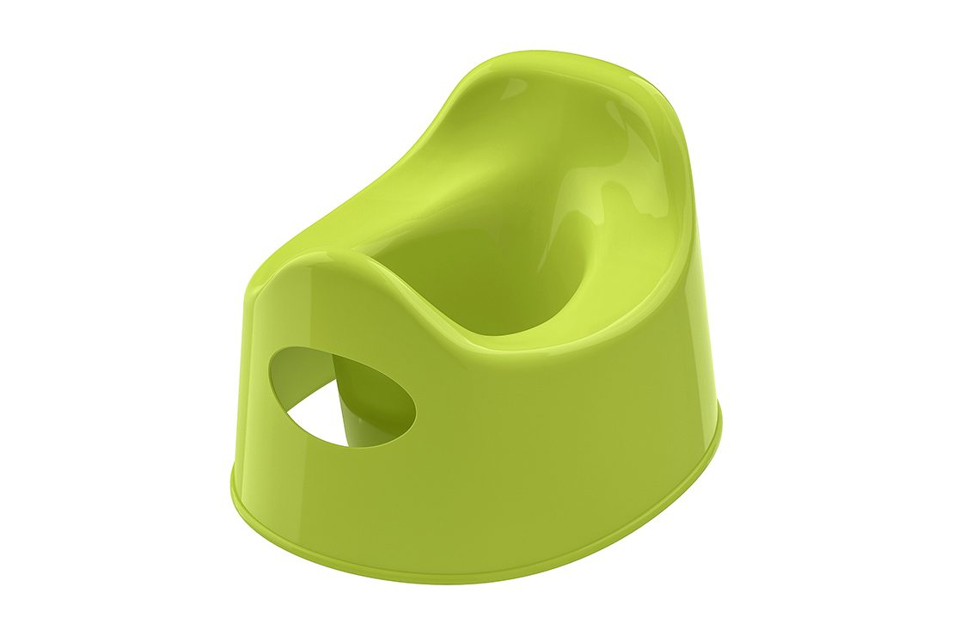 Child Potties

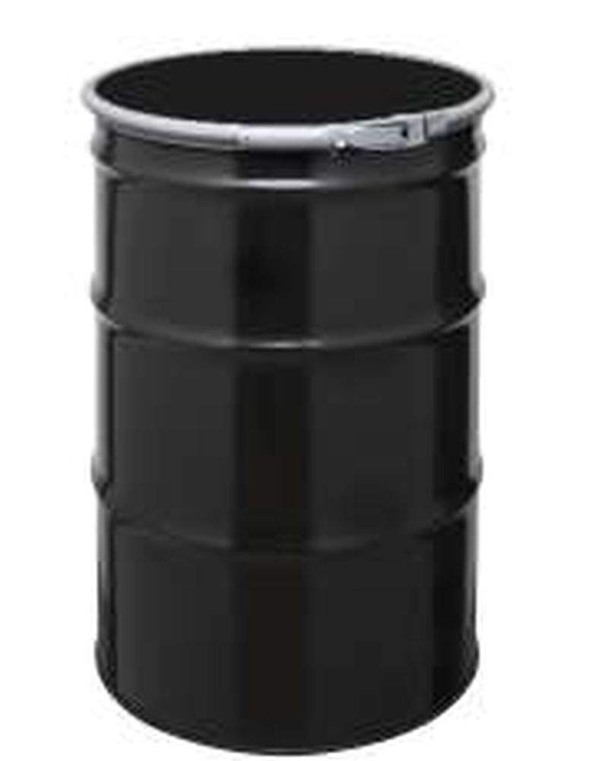 Steel barrels – 200 Litter (Open Top for Garbage)

Handheld broom with wooden handle

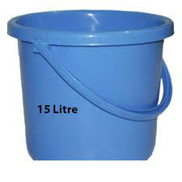 Bucket (15 litter capacity)

Hard held brush for latrine cleaning

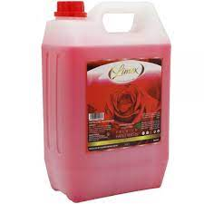 4 litter capacity liquid soap

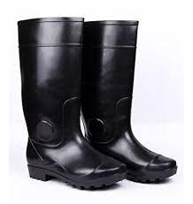 Gum boots

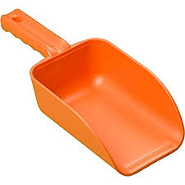 Dirt Scoopers

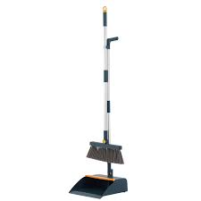 Hand held brush with scooper (set)

